Contents

1. Application Assignment1B overview 3

2. Screen designs and main functions 3

2.1 View 1 Form 3

2.1.1 New Shape 4

2.1.2 Update Shape 4

2.1.3 Delete Shape 4

2.2 View 2 Form 4

2.3 View 3 Form 5

2.3.1 New Shape 6

2.3.2 Update Shape 6

2.3.3 Delete Shape 6

3. Use case Diagram 6

4. Activity Diagrams 8

5. Class diagram 9

# Application Assignment1B overview

Application Assignment 1B has been created in Visio Studio 2015. The Assignment 1B “Main Form” is shown on Fig.1

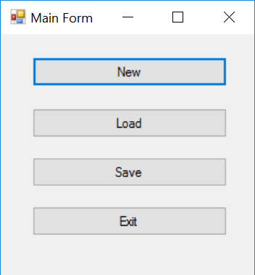

Fig 1. – Assignment 1B “Main Form”

Main form has following functionality:

-button “New” allows users to create a new project;

-button “Load” allows users to upload existing saved project using serialization;

-button “Save” allows users to save project using serialization;

-Button “Exit” allows user to close the project.

Assignment 1b has one super class IShape and three sub-classes PlaneShape, HelicopterShape and Cloud. User can create Plane, Helicopter and Cloud Shapes. Helicopter and Plane can’t be moved on the Cloud Shape.

# Screen designs and main functions

## View 1 Form

View 1 form is shown on Fig.2. It allows users to change shape position, add new shape, update existing shape and delete shape.

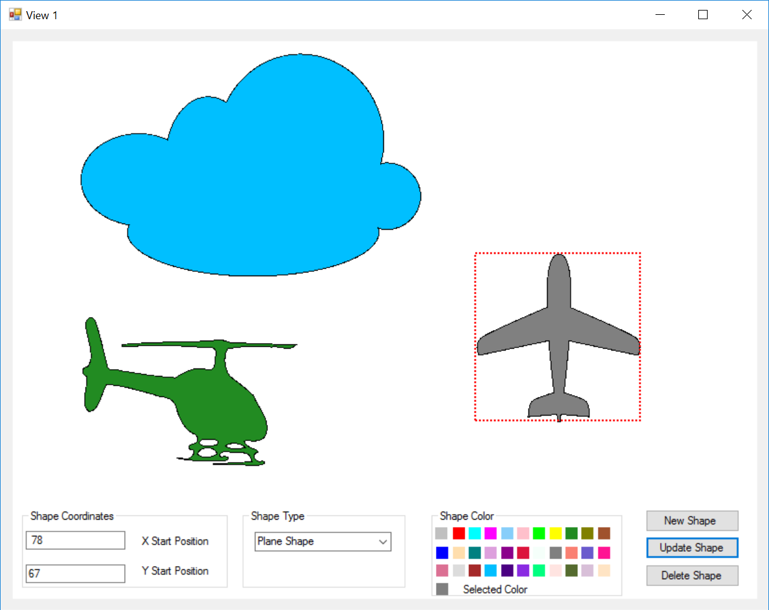

Fig. 2 – View 1 form

### New Shape

To create a new shape user should complete following fields:

-X Start Position;

- Y Start Position;

-Shape Type;

-Select Colour (Black colour is default).

User should click on button New.

New shape is created.

### Update Shape

To update existing shape user should select shape and change following fields (if required):

-X Start Position;

- Y Start Position;

-Select Colour (Black colour is default).

User should click on button Update Shape.

### 2.1.3 Delete Shape

To Delete shape user should select existing shape and click on button “Delete”.

## View 2 Form

View 2 doesn’t have any functions. It is just view screen. View 2 Form is shown on Fig. 3

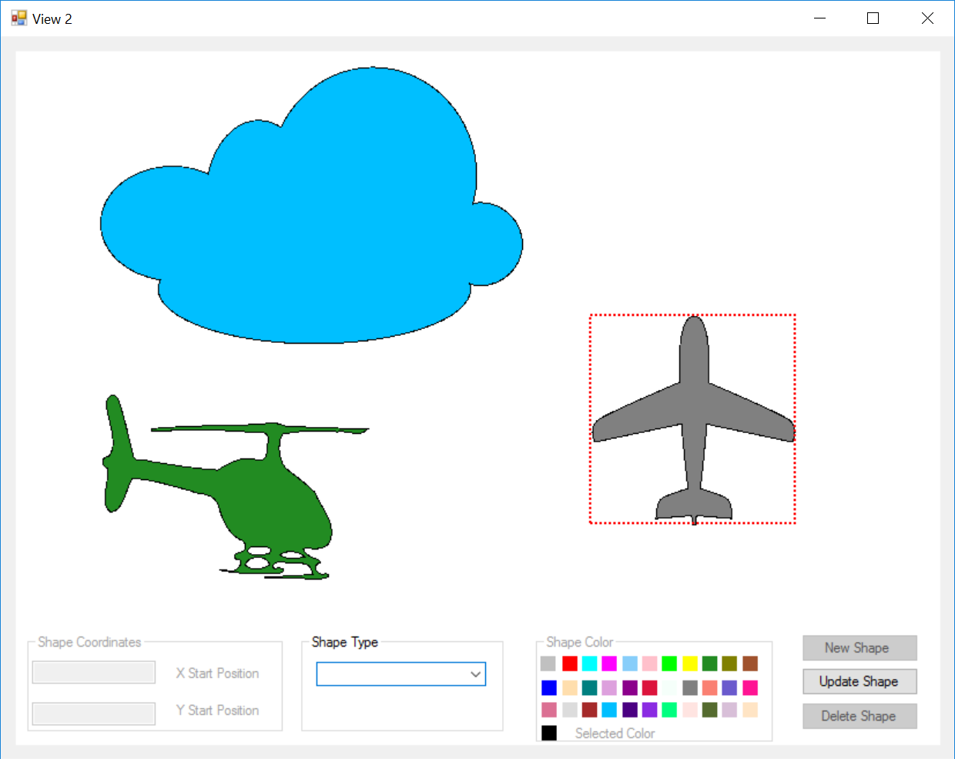

Fig. 3 – View 2 Form

## View 3 Form

View 3 form is shown on Fig. 4. It allows users to change shape position, add new shape, update existing shape and delete shape.

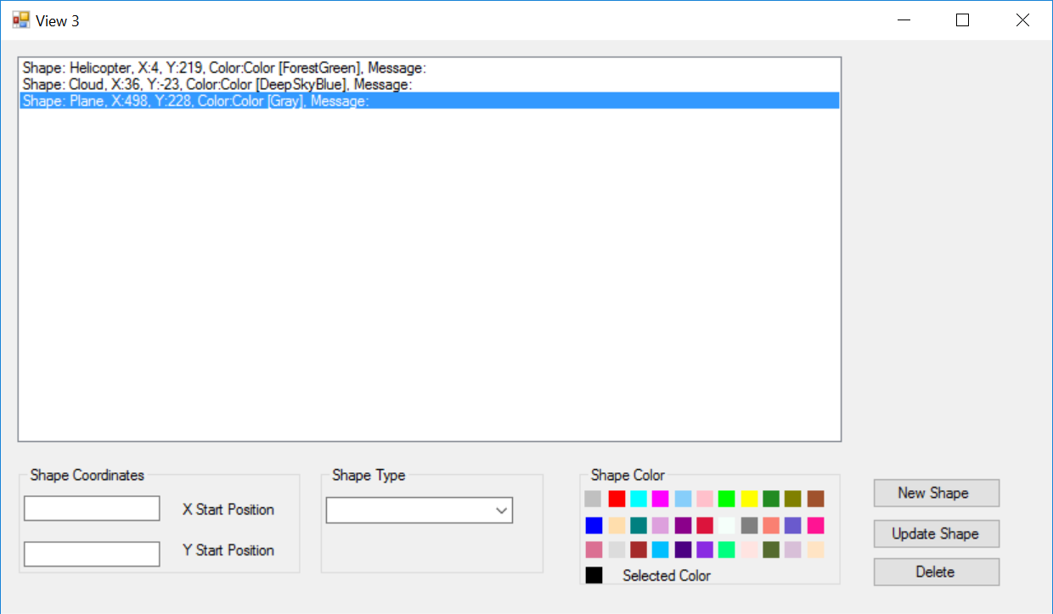

Fig. 4 – View 3 Form

### New Shape

To create a new shape user should complete following fields:

-X Start Position;

- Y Start Position;

-Shape Type;

-Select Colour (Black colour is default).

User should click on button New.

New shape is created.

### Update Shape

To update existing shape user should select shape and change following fields (if required):

-X Start Position;

- Y Start Position;

-Select Colour (Black colour is default).

User should click on button Update Shape.

### Delete Shape

To Delete shape user should select existing shape and click on button “Delete”.

# Use case Diagram

Main form of Assignment 1B allows user to:

* create new project;
* load existing project from the file;
* save project;
* exit.

Use case diagram for Main Form is shown on Fig. 5



Fig.5 – Use Case Diagram for Main Form

When user click on button “New” new project is created.

New project use case diagram is shown on Fig. 6

New project has three view forms.



Fig.5 – Use Case Diagram for Main Form

# Activity Diagrams









# Class diagram